Zirconia Oxygen Sensor Testing
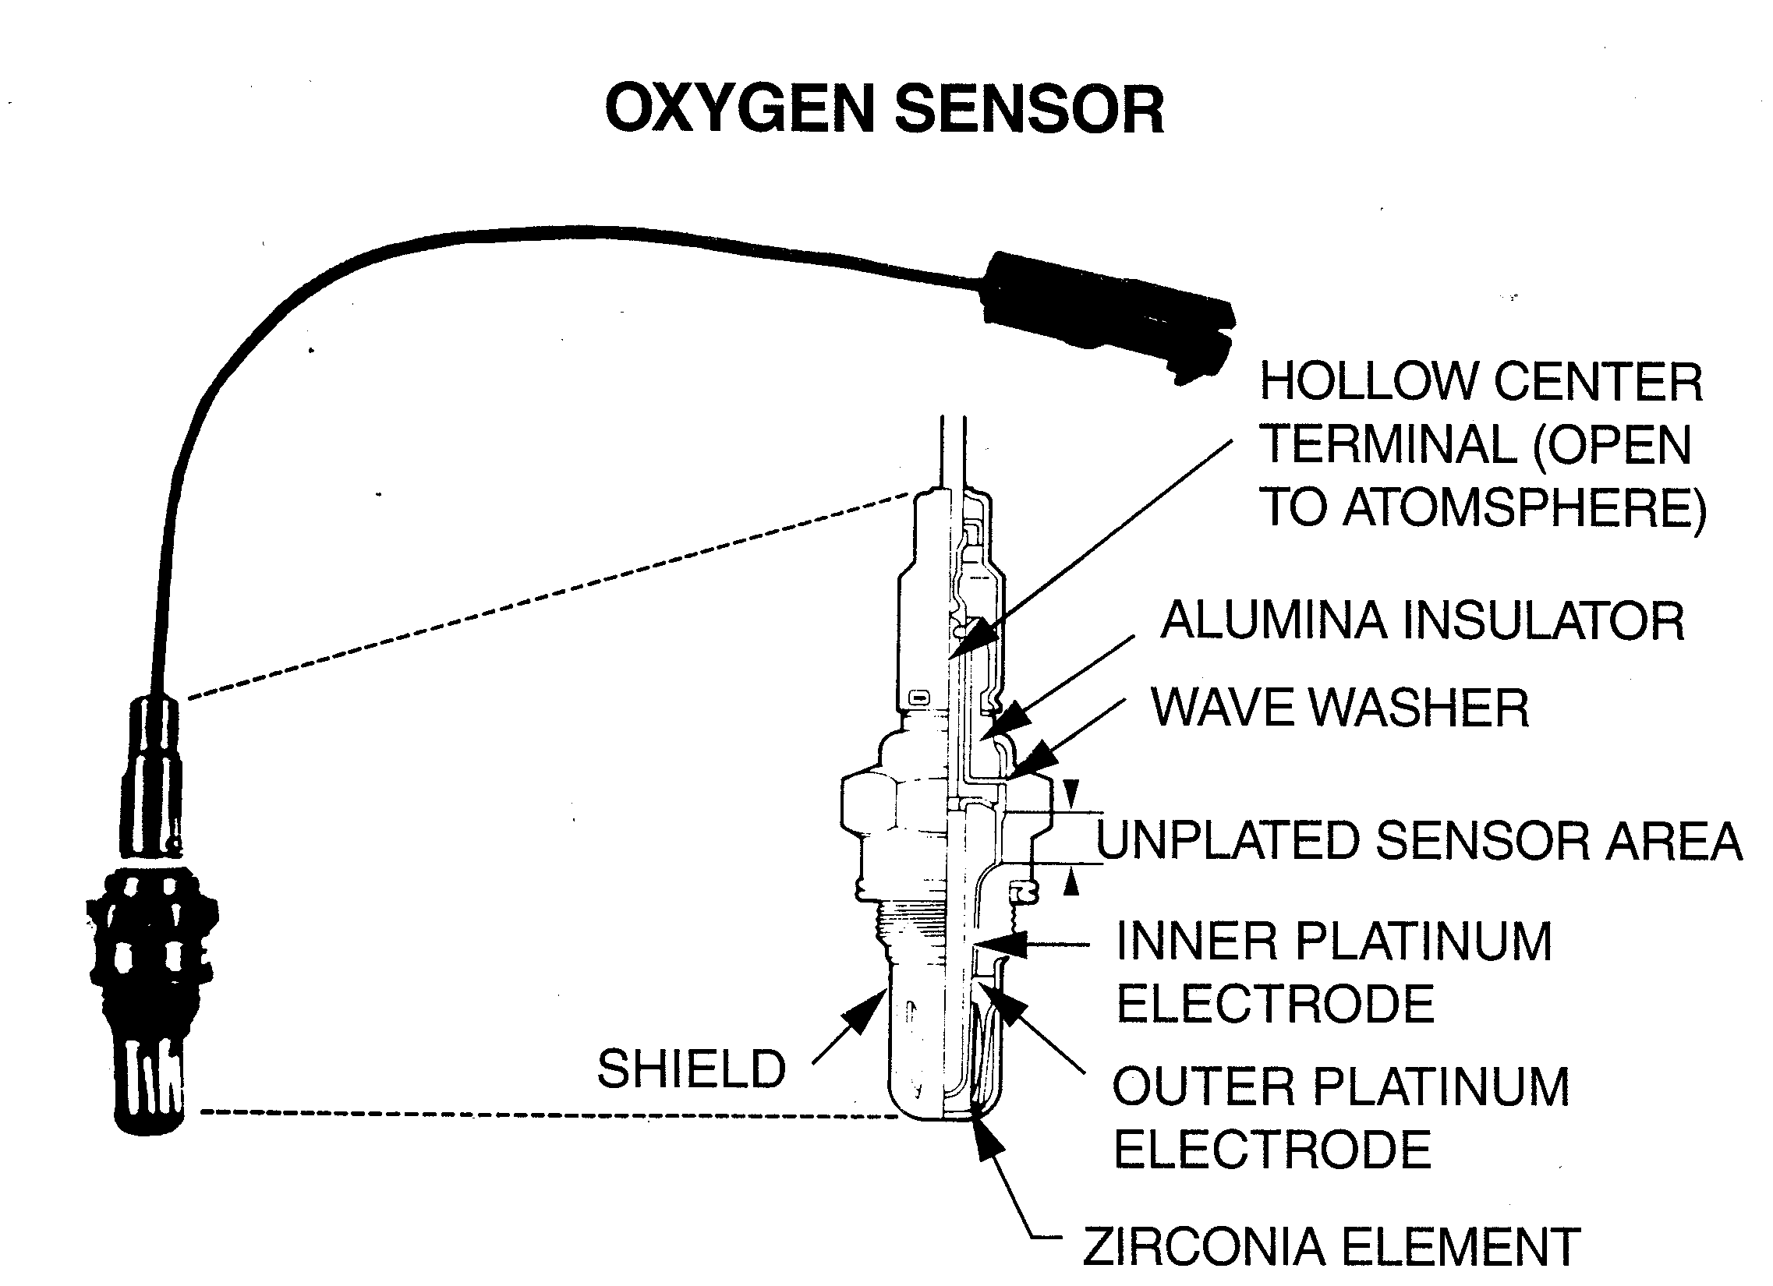
Used courtesy of General Motors.

Visual inspection:
As with all test procedures this is the first and most important.
- Make sure all connections are clean and tight, since we dealing with very low voltages any type of voltage drop will adversely effect system operation and may affect test results as well.
- Make sure O2 sensor is clean. The sensor must have a supply of Oxygen available to its external side at all times to operate properly. Mud, ice and anything else that coats the exterior of the sensor will cause erroneous readings through no fault of the sensor itself….keep it clean.
- Make sure there are no exhaust leaks between the engine and the O2 sensor. Anytime Exhaust can leak out of the system before crossing the O2 sensor you lose some signaling power at the sensor, corresponding to this, air may be sucked into the exhaust system between exhaust pulses due to negative pressure, further contaminating the reading.
- Be aware that a restricted exhaust may effect O2 readings.

Pre-test conditions:
Single wire, Run engine at 2000 R.P.M. for 3 minutes before starting test. O2 sensor does not become fully operational until approximately 650 degrees Fahrenheit, below that it will give low voltage signals. This also ensures vehicle is in “closed loop”.

Multiple wire, If more than one wire is present then sensor is equipped with a heater to ensure faster operation of O2 sensor. Normally a warm up time of under a minute is necessary.

Test Procedures:
- Through the use of a break out box or backprobing, tap into the O2 sensor signal wire with a D.V.O.M. or lab scope. Note: Never use any type of analog meter on an Oxygen sensor!
- Install test equipment with (+) side on O2 sensor, (-) side on battery negative. (or an alternate good ground source)
- With vehicle off, key on you may see 450 millivolts at sensor or at vehicle harness with sensor unplugged, this is normal.
- Ensure engine is sufficiently warmed up.
- Note voltage readings, should be fluctuating from above 450 millivolts to below 450 millivolts, fairly rapidly. Usually falling to about 2 to 300 millivolts before heading back up to between 6 to 750 millivolts. 450 millivolts is the perfect number the computer is trying to stay at so it’s constantly “switching” in an effort to maintain this.
- Run engine at 2000, voltage fluctuations should remain but the rate speed at which they occur should increase. If it does not it’s faulty. A lazy O2 sensor
- Snap throttle wide open, then release, if engine accelerates normally O2 sensor should rise momentarily to 900 millivolts minimum, then fall below 100 millivolts and return to normal. If it can’t reach 900 millivolts (weak) or doesn’t fall below 100 millivolts (lazy), it’s faulty. Note: exhaust must be voltage drop tested if a single wire sensor fails to read under 100 millivolts. Should be under .050 volt drop.
- Readings should not rise above 1.1 volts for any reason, If they do then you have a faulty O2 heater. It is leaking electrically into the O2 sensor circuit, causing higher voltages that would normally not be possible.
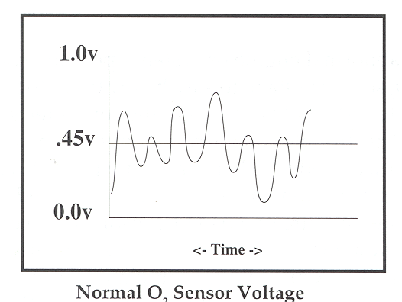

Run these test anytime an O2 sensor code has been set or you suspect a problem with the O2 sensor. If it passes, chances are the O2 sensor is O.K. and you should look elsewhere for the problem. The O2 sensor is commonly replaced during trouble code diagnostics when it is not the cause of the problem! Diagnostic trouble codes that report an overly rich or lean mixture are commonly caused by failures other than the O2 sensor, such as state of tune, fuel system problems, other sensor failures and the list goes on and on. We use these tests to verify that the O2 sensor is not the cause of the problem!

OBD 2 With the advent of OBD 2 diagnostic systems a new twist has been added to our O2 sensor discussion. O2 sensors can be categorized as either upstream or downstream. Simply put the O2 sensor in front of the catalytic converter is known as the “upstream” O2 sensor. The upstream sensor operates just like any other Zirconium O2 sensor, it is an input for the computer to fine-tune the fuel mixture. It also tests the same as above, so treat it accordingly. A new O2 sensor has been added to our system, the downstream O2 sensor. The downstream O2 sensor function is to monitor catalyst efficiency.

Downstream O2 sensor testing: Testing the downstream O2 sensor is fairly simple. While we watch our upstream O2 sensor switch from high to low and back again (200 – 750 – 200) our downstream sensor should follow it but in a very reduced fashion. For instance if our upstream sensor reads 200mV then our downstream sensor should read just under 450mV and if our upstream sensor reads 750 mV then our downstream sensor should read just over 450 mV. We will find that although it follows the front sensor lightly it should never go to far from 450 mV.
And that is the basis for testing the downstream O2 sensor, take the upstream sensor voltages into account and watch the downstream sensor, it should lightly follow but still stay around the 450 mV area

Common downstream failures: If downstream O2 sensor starts to have large switching voltages like and/or matching the upstream O2 sensor then your catalytic converter has become inoperative and should be serviced! The sensor did exactly what it was designed to do: warn the computer that the catalytic converter has failed.

How to kill an O2 sensor:
Contamination from:
Leaded Gasoline
Engine Coolant
Silicone
Extended Rich Mixture

Improper Handling:
Using analog meters
Dropping the sensor
Hammers
Piercing insulation

Original manuscript © 2000 by J.G.M.
http://www.careersnet.org/automotive/YVCC/ast130~1/Handouts/Engine%20Performance/Zirconia%20Oxygen%20Sensor%20Testing.doc

