Question : Does anyone know what is involved in fitting the 99 front end and lights onto a 92TT. I have all the parts but my body shop says I have to cut a large chunk out of the head light buckets. Is this true for the 99 lights to fit I don't want to cut if i don't have to..

Replys :
The 2nd gens (1999) have different headlight buckets (the part of the frame the headlight bolts into) The first gen buckets don't have clearance for second gen lights. So you need to trim the outer edge of the headlamp buckets in order for the larger projection beam housings to fit in properly. Also, there are no mount/screw holes along the inner edge of the headlamp buckets, so you will have to tap mount holes .

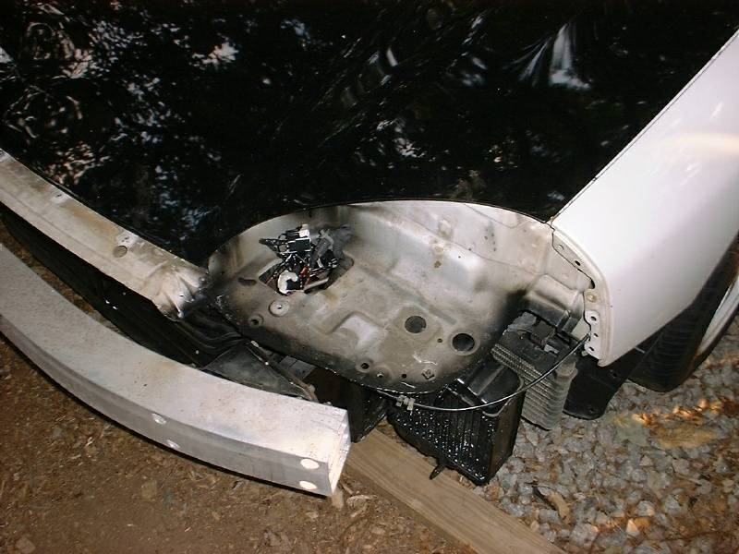

Good shops will be able to weld brackets on the lip of the headlight bucket cause when you make quick cuts, you end up cutting too much and the light sits too low in the bucket. So they use these brackets to hold the light up at the proper height. They aren't directly related to mounting. The absolute easiest and most cost effective way to do this is to take your time and measure everything perfectly. Make a perfect cut from the bucket so you have perfect lip at the right height so the light doesn't sit too low. Then use the one mounting point that lines up and the one by the turn signal and you should be all set.

Hood Open  Headlamp Mounting  Comparison  Left:  1991 - 1993  Popup Style  Right:  1994 - 1998  Projection Style  1999  Projection Style | 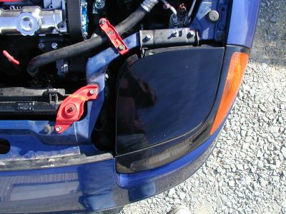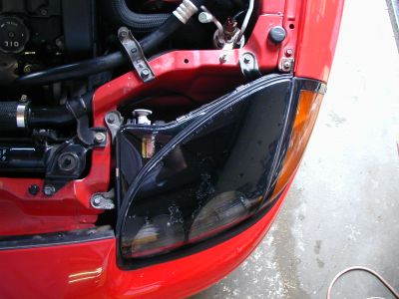  This is hopefully what it should look like ! this is a 99 light The same 99 style front end is also affixed. See how flush it is!  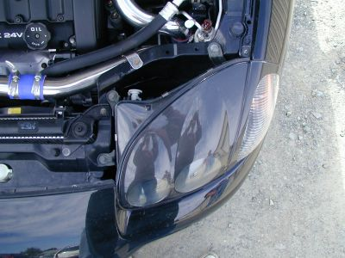

This is what my body shop did for me . I gave them this document with the pictures shown above, and this is what they did.

